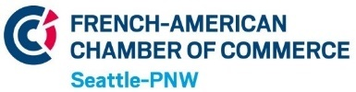 |  | High-Tech & Innovation Committee |  |  |  | INNOVATION, INDUSTRY TRENDS  HIGH-TECH STARTUP, NETWORK,
HOME | ABOUT |  |  | PAST EVENTS | FUN FACTS | CONTACT US
COMING EVENT
 |  |  | AGENDA |  |  | REGISTER
SOME OF OUR PAST EVENTS
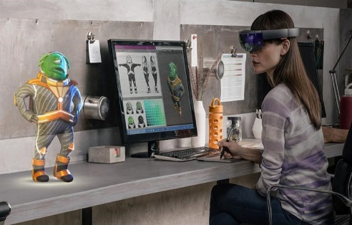 |  |  | 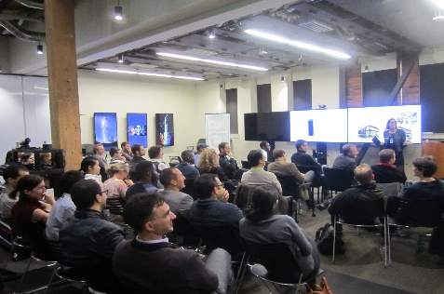 |  |  | 
MICROSOFT Research, April 2016  Cutting-edge innovations: HoloLens, Surface Hub, Avatars, Voice Translator, and more.  86 attendees, 38 companies |  |  | AMAZON Echo & Alexa, Feb 2016  68 attendees, 25 companies |  |  | EXEQUO, Video Games, March2016
FOOTER NOTE

(new web page - ABOUT)
MISSION
The FACC High-Tech and Innovation Committee is a group established by the French-American Chamber of Commerce of the Pacific Northwest (FACC PNW). Its purpose is to create an active network of French-speaking individuals (“Franco-phones”) and French / American companies sharing a common interest in High-Tech and Innovation
Videos

Board of directors
  Put Black & White | Philippe Battel  Description  linkedin LINK ?  email ? | PICTURE | David Sanguin  Description
PICTURE | Marion Desmazieres | PICTURE | Anne-Chloe Wambre
PICTURE | Benjamin Orillon | PICTURE | Alexandre Zanghellini  Description

French-American Chamber of Commerce
PICTURE | Jack A. Cowan  Description  linkedin LINK ?  email ? | PICTURE | Claire Bouchot
PICTURE | Pankaj Parag
COMPANIES
(see word file)
Back

(new webpage)
PAST EVENTS

Back

(new webpage)
FUN FACTS
(see PPT attached)

CONTACT US
FACC email only, our emails, other ?

Back

